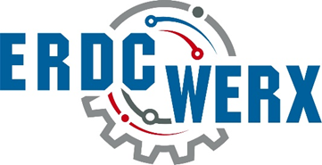

ERDC CHL Dredging Solutions for Improved Navigation
White Paper Template
Three-Page White Paper

Suggested White Paper Format: maximum of 3 pages not including cover page, single space text, Times New Roman size 12 font, normal margin, saved as PDF and submitted as attachment to submission form. Note: please title your white paper document as follows: Dredging Solutions for Improved Navigation followed by the first two words of the submitting entity name.
Proposed Solution List and briefly describe the proposed solution.
Applicability of Solution Provide a concise explanation of how the proposed solution meets each of the specified requirements.
1. Type of technology
2. Vendor or Developer name and contact information and relevant experience
3. Engineering specifications
4. Implementation examples (if available)
5. Installation methods: labor, special tools, etc.
6. Typical cost of materials and installation
Other Details Please provide additional details that help to explain the applicability of this solution. Include links to supplemental information including photos, diagrams, and reports.

